Firmware Update and Device Management Instructions:
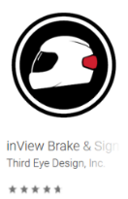
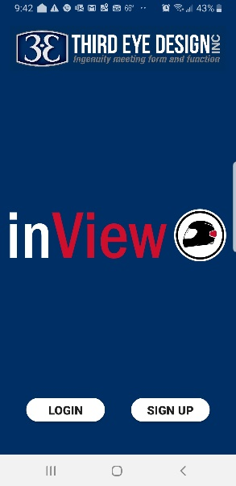
The inView® IOS and Android smart phone and tablet application provides a complete management tool to update, test and operate your inView® system.
The inView® Application works in the exact same way on both platforms. Please start by downloading inView® Brake & Signal Light from the appropriate app store.
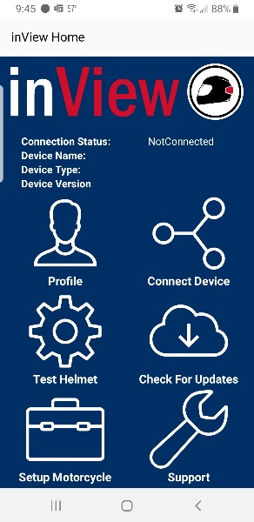
Once the application has downloaded, open the app and complete the registration process by clicking on the sign-up button (see right). This will allow you to register inView and add your motorcycle(s) to your garage.
Once registered, you will get to the menu screen (see left). Here you can:
Update your profile
Connect to your helmet unit
Test the helmet unit functionality
Check for updates for the device you are connected to
Contact support

When you Connect Device, you will see your helmet and motorcycle devices appear (see right). Simply click on the device to connect.
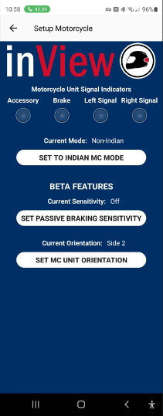
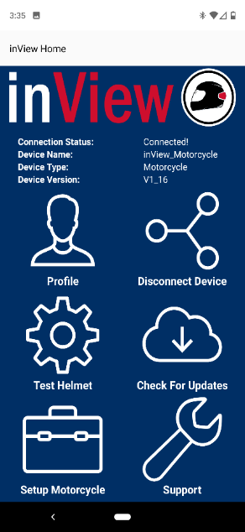
Once connected you will be returned to the main menu screen and your device will show as connected (image left). From here, you can Check for Updates operate the helmet light and test operation of the motorcycle transceiver. To operate the helmet (see below right), simply press on the helmet function you wish to test. Please be sure to” disconnect device” from the main screen (use back arrow) when you are done!
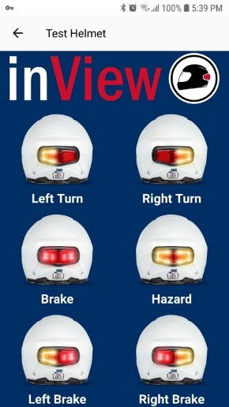
To test the motorcycle transceiver, simply turn on your motorcycle, select “Connect Device” connect to then select inView_Motorcycle then “Setup Motorcycle” from the main screen. From here you can set the transceiver to Indian Mode if you have it installed it on an Indian Motorcycle, enable passive braking and watch the virtual LEDs at the top of the Setup Motorcycle screen illuminate with brake and turn signal activation.

